4.49: a)
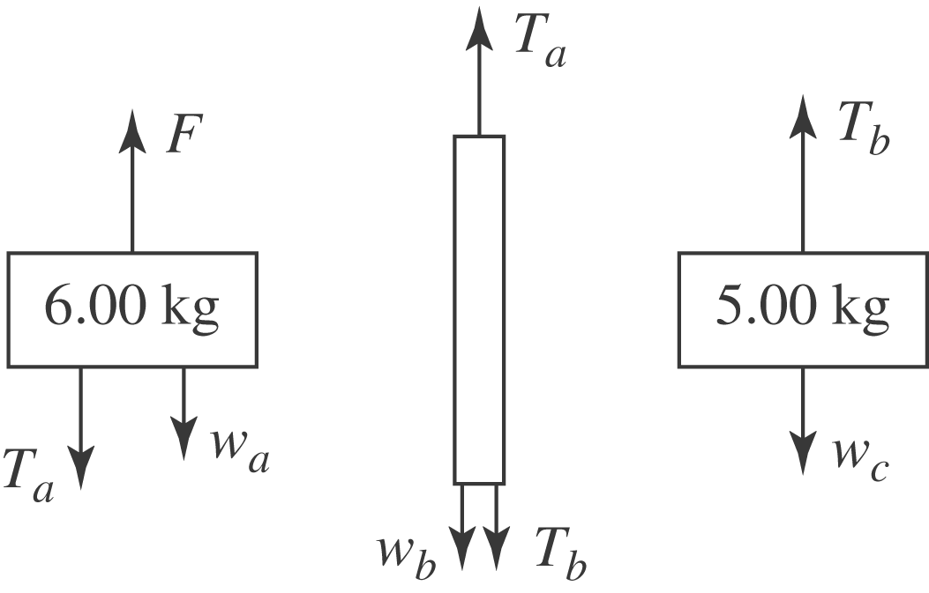
b) The net force on the system is (keeping three figures), and so the acceleration is 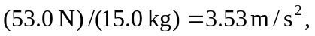up. c) The net force on the 6-kg block is 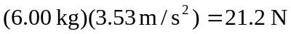, so the tension is found from 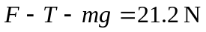, or . Equivalently, the tension at the top of the rope causes the upward acceleration of the rope and the bottom block, so 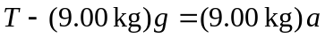, which also gives 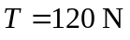. d) The same analysis of part (c) is applicable, but using 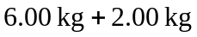 instead of the mass of the top block, or 7.00 kg instead of the mass of the bottom block. Either way gives 

